**Remote Control of Fluorostat**

1. Log in, password: fluorostat
2. From the app launcher 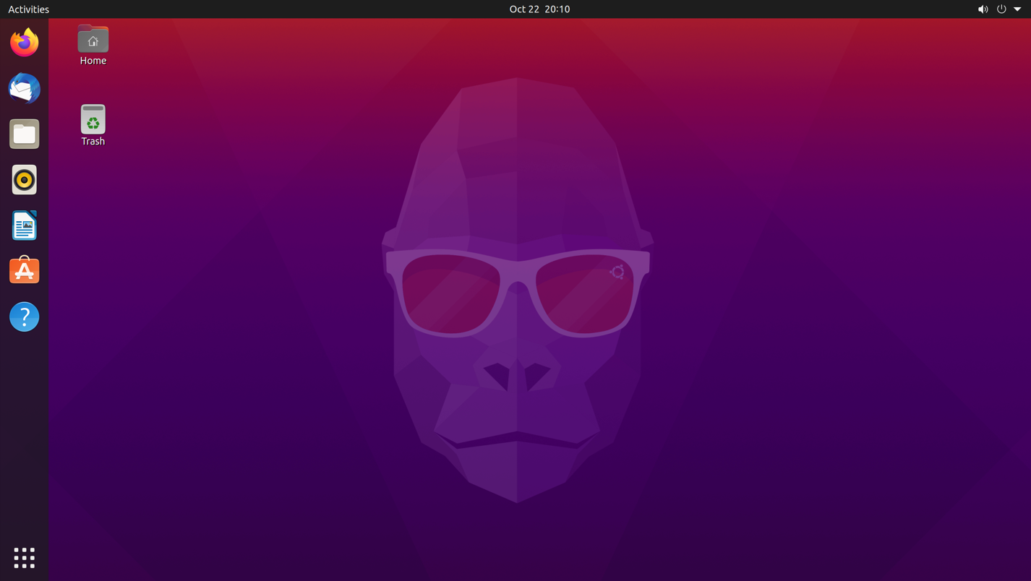 find and select chrome remote desktop

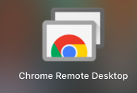

1. At the top of the window, select remote support

1. Select Generate code

1. Send code to support giver, they can now log in to the fluorostat computer

**Starting an LD run**

The only difference between the LD runs and other runs is the Arduino code.

File: Arduino code TwoColors_Air_LD_chem_v2 (the same one that should already be open)

At the top of the script make sure the following variables are set:

Target_OD = 600

Delaytime = ((*Hr*L * 60L + *Min*L) * 1000L +60L)

Where *Hr* is the number of hours till the first night transition and

*Min* is the number of minutes until the first night

Since the Arduino doesn’t have a clock you have to give it this time as a reference point.

Night should fall at 9 pm, so for example if you were starting the run at 2:15 pm, 9 pm is 6 hrs and 45 mins away so the variable would be ((*6*L * 60L + *45*L) * 1000L +60L)

Transtime = (12 * 1000 * 3600L) 12 hours for both night and day

OD setpoint: 600

Length of day/night

Mins till night

Hours till night

In the loop, comment out other lines and uncomment turbidostat_cyano_air_LD(…) and upload

